**Notes regarding W&M setup in Azure and IDs needed for apps.**

Web API (***placeholders are bold italics***):

In the application the Azure AD settings are set in appsettings.json. The following values come from the App Registration in Entra ID.

"AzureAD": {

"Instance": "https://login.microsoftonline.com/",

"Domain": "***actual.domainname.onmicrosoft.com***",

"TenantId": "***actualtenantid***",

"ClientId": "***actualclientid***",

"CallbackPath": "/signin-oidc",

"ApiScopes": "api://***actualclientid***/api.read" ← **api.read is a custom scope created in the App Registration and Granted for Default Directory.**

Appsettings.json also contains a connection string named “DefaultConnection”, this value should be superseded by the value in the expected environmental variable on the container "***ConnectionStrings__DefaultConnection***".

API permissions in Azure:

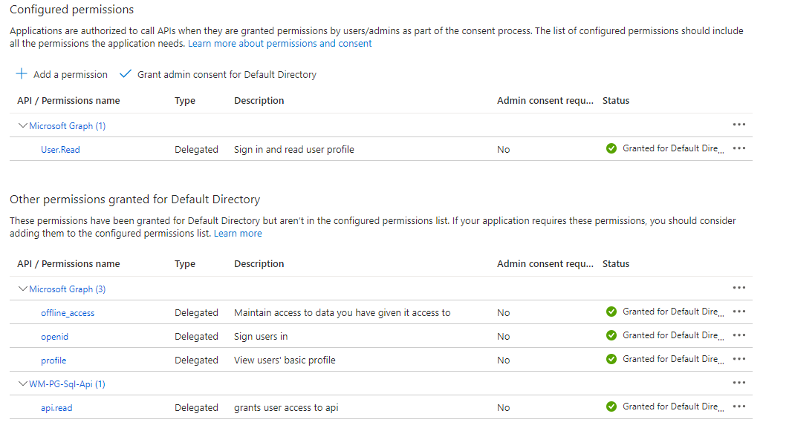

Expose an API in Azure (grant the desktop and mobile app access to the API):

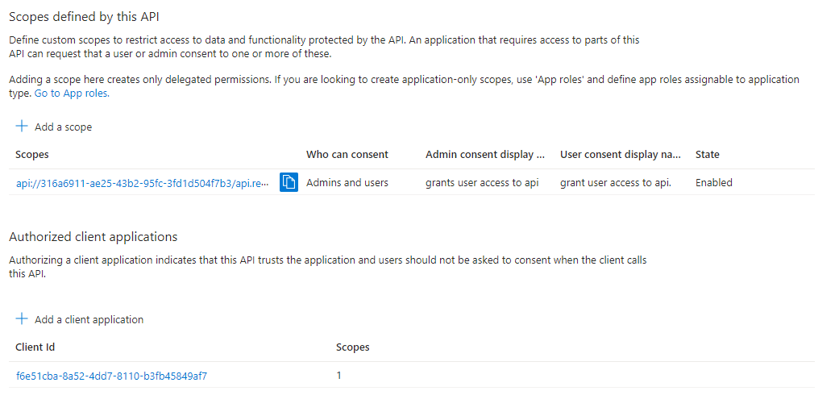

Desktop and Mobile applications (***placeholders are bold italics***):

The following values come from the Entra ID App Registration for the Desktop and Mobile app.

The actual uri to the web api must be passed into the desktop application.

httpClient = New HttpClient With {

.BaseAddress = New Uri("https://***webapi***")}

In the desktop application the following is passed into the MicWrapper library.

objAuth = New Auth(New AzureAdOptions() With {

.Instance = "https://login.microsoftonline.com/",

.TenantId = "***actualtenantid***",

.ClientId = "***actualclientid***",

.RedirectUri = "http://localhost",

.Scopes = "api://***actualclientid***/api.read",

.GraphScopes = "user.read"})

In appsettings.json in the mobile app.

"AppSettings": {

"ServiceUrl": "https://***webapi***/"

},

"AzureAD": {

"Authority": "https://login.microsoftonline.com/{0}",

"TenantId": "***actualtenantid***",

"ClientId": "***actualclientid***", ← **The client id for the desktop and mobile registration is unique from the web api.**

"RedirectURI": "http://localhost",

"AndroidRedirectUri": "msal***actualclientid***://auth",

"ApiScopes": "api://***webapiclientid***/api.read",

In addition to changes in appsettings.json the AndroidRedirectUri must be set in the AndroidManifest.xml file.

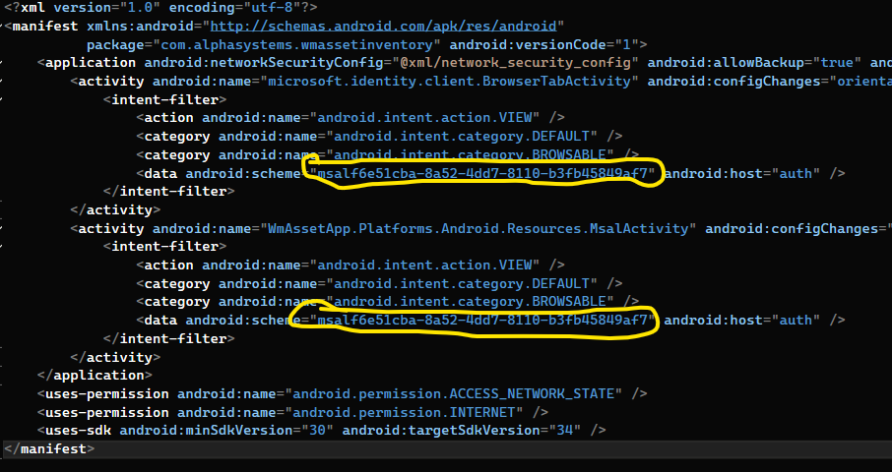

As well as in MsalActivity.cs.

